**DATA FLOW DIAGRAM**

|  |  |
| --- | --- |
| **Date** | November 2nd, 2023 |
| **Team ID** | PNT2022TMIDxxxxxx |
| **Project Name** | ASL- Alphabet Image Recognition |
| **Maximum Marks** | 4 Marks |

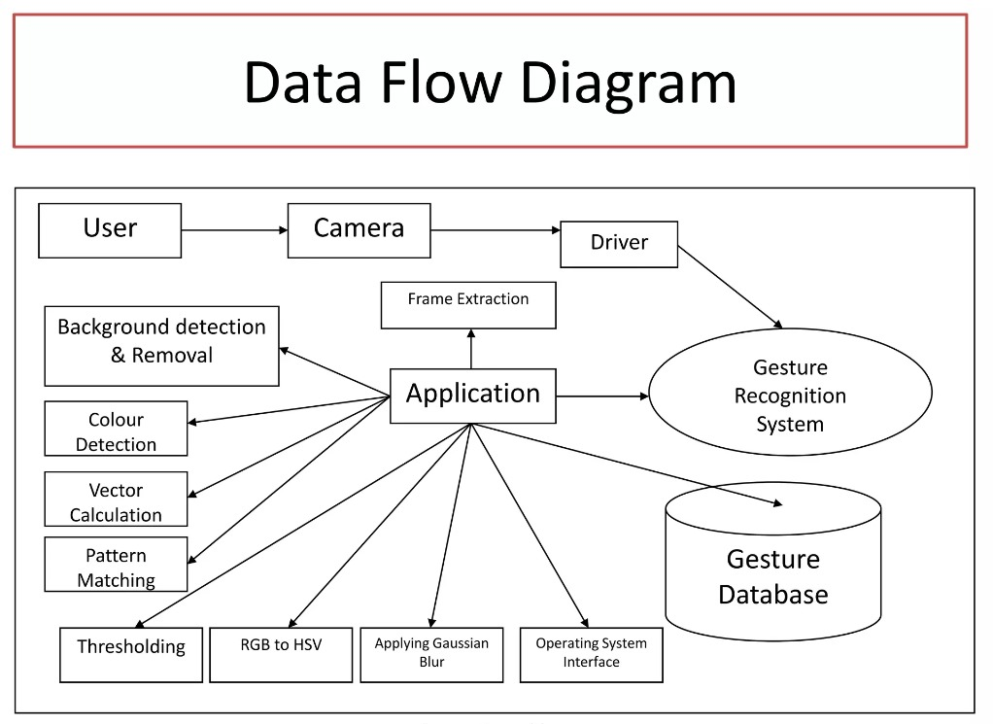

**USER STORIES DIAGRAM**

|  |  |  |  |  |  |  |
| --- | --- | --- | --- | --- | --- | --- |
| User Type | Functional Requirement | User Story Number | User Story/Task | Acceptance Criteria | Priority | Release |
| ASL Learner | Recognition | US-01 | Sign Recognition | As an ASL learner, I want to sign a word or phrase, and the system should recognize and display the corresponding ASL sign or translation. | High | v1.0 |
| ASL Teacher | Verification | US-02 | Student Sign Verification | As an ASL teacher, I want to verify and correct my students' ASL signs using the system. | High | v1.0 |
| Deaf User | Translation | US-03 | Sign-to-Text Translation | As a deaf user, I want the system to convert ASL signs to text or speech to assist in communication with hearing individuals. | High | v1.1 |
| System Administrator | Monitoring | US-04 | System Performance Monitoring | As a system administrator, I want to monitor the system's performance and usage statistics. | Medium | v1.1 |
| Researcher | Data Collection | US-05 | User Interaction Data Collection | As a researcher, I want to collect data on user interactions and system performance for analysis. | Medium | v1.2 |
| Mobile App User | Mobile Accessibility | US-06 | Mobile App Access | As a mobile app user, I want to access the ASL sign recognition system on my smartphone. | High | v1.2 |
| Web App User | Web Accessibility | US-07 | Web App Access | As a web app user, I want to access the ASL sign recognition system through my web browser. | High | v1.2 |
| Security Officer | Data Security | US-08 | Data Security & Privacy | As a security officer, I want user data, especially video streams, to be securely processed and stored. | High | v1.3 |
| Scaling Needs | Performance | US-09 | System Scalability | As the project scales, I want the system to handle an increasing number of users without compromising recognition accuracy or performance. | High | v1.3 |
| User Feedback | Feedback Mechanism | US-10 | Built-in Feedback Mechanism | As a user, I want a built-in feedback mechanism to report recognition inaccuracies and other issues. | Medium | v1.4 |
| User Profiles | Personalization | US-11 | User Profile Management | As a user, I want the system to store my preferences and usage history for personalization. | Medium | v1.4 |
| Sign Language Interpreter | Real-time Interpretation | US-12 | Real-time Interpretation | As a sign language interpreter, I want the system to assist me in real-time interpretation. | High | v1.5 |

This table provides a structured overview of user stories, their respective functional requirements, acceptance criteria, priorities, and planned releases for the ASL sign recognition project. It helps in organizing and prioritizing the development tasks.